SIMATS ENGINEERING
ASSESSMENT TOOL 2: Case Study

COURSE NAME: | Cloud Computing and  Big Data Analytics | COURSE CODE: | CSA15

COURSE OUTCOME COVERED
CO3: Implement cloud-based solutions using cloud storage, web APIs, and platform services for real-world applications. (BL3)

Dave's Taxonomy: Precision (Level 3)  Question Count: 3 | Total Marks: 30

Code of Conduct
I Rakkesh Karan R(192524253)certify that this submission is my original work and that I have adhered to the guidelines specified for this assessment.
I understand that any violation of academic integrity rules will result in disciplinary action. Signature of the student:

Assessment Tasks Case Study
- Case Study 1: Smart Retail Inventory Management System

A retail chain implements a cloud-based inventory system connected to store devices.Clients (POS systems and dashboards) communicate via APIs to centralized cloud services. Cloud storage stores product data, transaction logs, and analytics datasets. The system uses platform services for analytics and demand forecasting. Secure access is maintained through VPNs, firewalls, and API gateways. This solution integrates infrastructure, services, and web applications for efficient operations.

Case Study 2: Cloud-Based Document Collaboration System

An enterprise deploys a document collaboration tool similar to Google Docs. Users access the platform via browsers, enabling real-time editing and sharing. Documents are stored in distributed cloud storage with version control mechanisms. Web APIs enable synchronization across multiple clients and devices.
Network infrastructure ensures low latency and high availability globally. Security includes encryption, identity management, and access permissions for collaboration.

Case Study 3: Online Food Ordering Platform

A startup builds a cloud-based food ordering system accessible via web browsers and mobile clients.
Frontend clients interact with backend services through RESTful Web APIs hosted on a cloud platform.
Cloud storage is used to store menu images, invoices, and customer data securely. The infrastructure uses virtual machines and managed Kubernetes for scalability and reliability. Security is enforced through authentication tokens, HTTPS, and role-based access control. The system demonstrates integration of clients, APIs, storage, and platform services in real time.

Case Study Rubric
Criteria | Weightage | Level 4 - Exemplary | Level 3 - Proficient | Level 2 - Developing | Level 1 - Beginning
Understanding of Case | 25% | Clearly  identifies all technical and business  requirements | Identifies most requirements | Basic understanding only | Poor understanding of case
Application of Concepts | 25% | Applies  suitable cloud concepts and tools effectively | Good application with minor issues | Partial application | Weak or incorrect application
Analysis | 20% | Strong analysis with clear trade-off  reasoning | Reasonable analysis | Limited analysis | Minimal analysis
Solution Design | 20% | Solution is feasible, practical, and well justified | Reasonable solution with minor gaps | Basic solution | Unclear solution
Clarity | 10% | Well-structured and easy to  follow | Mostly clear | Somewhat unclear | Poorly organized

Assessment
Case study

CASE STUDY 1: SMART RETAIL INVENTORY MANAGEMENT SYSTEM

Introduction
A retail chain operates multiple stores, and each store uses devices such as Point-of-Sale (POS) systems and management dashboards. These devices continuously generate information about products, sales transactions, stock levels and customer purchases.
As the number of stores increases, managing this information using separate systems becomes difficult. The retail chain therefore implements a cloud-based inventory management system that connects store devices to centralized cloud services through APIs.
The cloud environment stores product data, transaction logs and analytics datasets. Platform services are also used to analyse the collected information and perform demand forecasting. This allows the retail organization to make better decisions regarding stock availability and future product demand.
Since the system is connected to multiple stores and handles business information, secure communication is maintained using VPNs, firewalls and API gateways.
Business Requirements
The system needs to provide a common inventory platform for all stores. Store employees should be able to update and retrieve inventory information through their POS systems.
Management should be able to monitor inventory and sales information through dashboards. The system should also support analytics so that historical sales information can be converted into useful business insights.
Another important requirement is demand forecasting. The retail chain should be able to estimate future demand based on previously collected transaction information.
The system must also remain secure because unauthorized access to inventory and transaction information could affect business operations.
Existing Challenges
One of the major challenges is distributed data. Different stores generate their own product and transaction information, making it difficult to obtain a centralized view of the entire retail chain.
Large numbers of transactions can also create a significant storage requirement. The system should therefore provide flexible storage that can handle increasing data volumes.
Another challenge is communication between different applications. POS systems, dashboards and cloud services need to exchange information efficiently.
Security is also important because the system communicates with several external store devices. Uncontrolled API access or insecure network connections could expose business information.
Finally, the organization needs to analyse historical data to identify sales trends and predict future demand.
Proposed Cloud-Based Solution
A centralized cloud-based architecture is proposed for the retail chain.
Store POS systems communicate with cloud services through web APIs. An API gateway can provide a controlled entry point for these requests.
The information received from different stores is stored in cloud storage. This creates a centralized repository for product data, transaction logs and analytics datasets.
The stored information can then be processed by cloud platform services. Analytics tools can identify sales patterns, while demand forecasting services can estimate future inventory requirements.
Managers can access the results through dashboards.
Architecture
The overall data flow can be represented as:
Store POS Systems
↓
VPN / Secure Network
↓
API Gateway
↓
Cloud Platform Services
↓
Cloud Storage
↓
Analytics & Demand Forecasting
↓
Management Dashboard
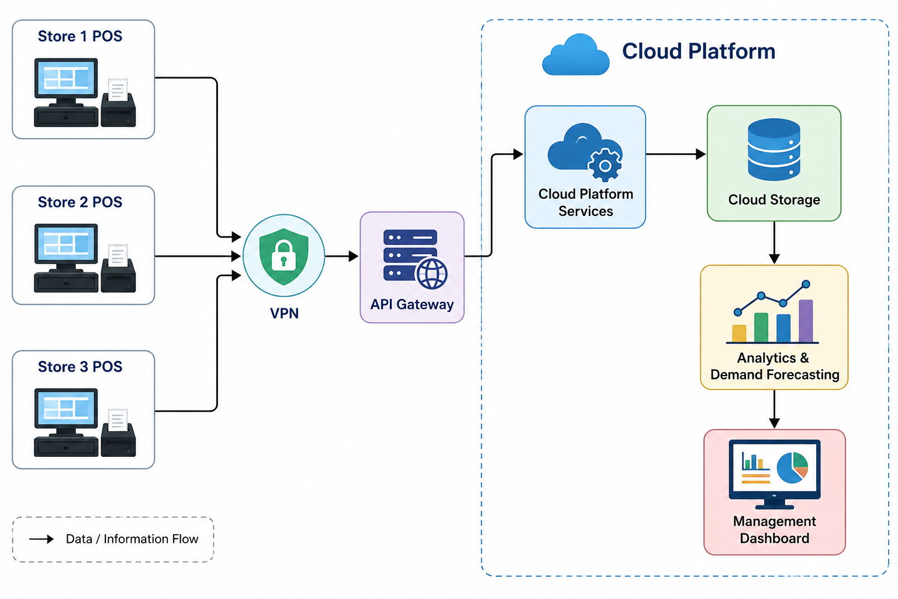

Role of Cloud Storage
Cloud storage provides a centralized location for product information, transaction logs and analytics datasets.
Instead of maintaining separate storage systems for individual stores, the organization can maintain its information within the cloud environment. Authorized applications can access the required data through cloud services.
As the number of stores and transactions increases, the storage requirement can also increase. A cloud-based approach is therefore more flexible than relying on fixed local storage.
Role of Web APIs
Web APIs act as the communication mechanism between POS systems, dashboards and cloud services.
For example, when a customer purchases a product, the POS system can send the transaction information through an API. The cloud service can process the request and update the appropriate inventory information.
Similarly, dashboards can request inventory and sales information through APIs.
This creates a standard communication mechanism between different components of the system.
Analytics and Demand Forecasting
The system collects transaction information over time. This information can be analysed to identify:
- Frequently purchased products
- Sales trends
- Changes in customer demand
- Stock requirements
- Products with low or high demand
Demand forecasting can then use this information to estimate future requirements.
For example, if a particular product consistently experiences high demand during a specific period, the retailer can prepare sufficient stock in advance.
This helps reduce both stock shortages and unnecessary overstocking.
Security
Security is maintained through several layers.
A VPN can provide a secure connection between retail stores and the cloud environment.
Firewalls can control network traffic and prevent unauthorized connections.
An API gateway can act as a controlled access point for API requests and help manage communication between store applications and cloud services.
Access to cloud data should also be limited to authorized applications and users.
Analysis and Trade-Offs
The cloud solution provides centralized data management, scalability and easier access to analytics. It also reduces the difficulty of maintaining independent inventory systems at every store.
However, the architecture depends on network connectivity between stores and cloud services. If connectivity is unavailable, communication with cloud services may be temporarily affected.
There may also be additional cloud service costs as the amount of stored data and number of transactions increase. Despite these considerations, the benefits of centralized management, analytics and scalability make the cloud solution appropriate for a large retail chain.
Expected Benefits
The proposed system provides:
- Centralized inventory management
- Easier access to information from multiple stores
- Scalable cloud storage
- Efficient API-based communication
- Analytics and demand forecasting
- Secure store-to-cloud communication
- Better inventory planning
- Improved management decision-making
- Easier integration of additional stores
Conclusion
The proposed cloud-based inventory management system provides an effective solution for connecting multiple retail stores with centralized cloud services. Cloud storage manages product and transaction information, web APIs provide communication, and platform services support analytics and demand forecasting.
VPNs, firewalls and API gateways provide secure access to the system. Overall, the architecture is practical, scalable and suitable for the retail chain's growing inventory and analytics requirements.

CASE STUDY 2: CLOUD-BASED DOCUMENT COLLABORATION SYSTEM

Introduction
An enterprise requires a document collaboration platform similar to Google Docs. The system allows users to access documents through web browsers and perform activities such as real-time editing and sharing.
The platform must support multiple users working on documents from different locations and devices. Documents are stored using distributed cloud storage, while web APIs provide synchronization between clients.
Since users may modify documents at different times, the system also requires version control. Security mechanisms such as encryption, identity management and access permissions are required to protect enterprise documents.
Business Requirements
The system should allow users to access documents through browsers without requiring the documents to be stored permanently on individual devices.
Multiple users should be able to work with shared documents and receive updated information.
The system should synchronize documents across multiple clients and devices.
Previous versions of documents should be maintained so that users can identify or recover earlier versions when necessary.
The platform should also provide high availability and low latency for users accessing the system from different geographical locations.
Security is another major requirement because enterprise documents may contain confidential information.
Existing Challenges
Traditional file-sharing systems may result in multiple copies of the same document. Different users may edit different copies, creating difficulty in identifying the latest version.
Another challenge is synchronization. When several devices access the same document, changes need to be reflected across clients.
Storage is also important because the enterprise may have a large number of documents. The storage system should be reliable and available.
Finally, shared documents create security concerns. A user should not automatically receive access to every document in the organization.
Proposed Cloud-Based Solution
A cloud-based document collaboration platform is proposed.
Users access the system through web browsers. The web application communicates with backend services through web APIs.
Documents are maintained in distributed cloud storage. The system can synchronize changes across clients using APIs.
A version-control mechanism maintains different versions of documents. This allows the system to preserve document history.
Security is implemented through encryption, identity management and access permissions.
Architecture

The proposed architecture is:

Users / Browsers
↓
Web Application
↓
Web APIs
↓
Distributed Cloud Storage
↓
Version Control

Security mechanisms operate across the system.
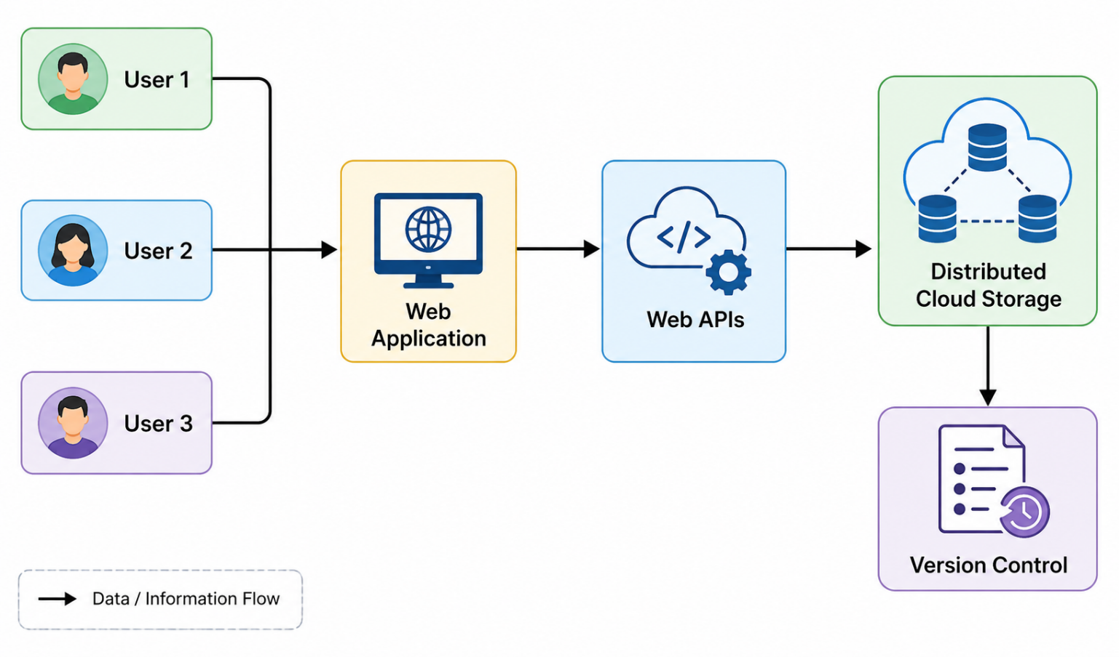

Encryption
Identity Management
Access Permissions
Real-Time Collaboration
The major feature of the system is real-time collaboration.
When a user modifies a document, the change must be communicated to the cloud service. Other authorized users accessing the same document can then receive the updated information.
Web APIs provide the communication mechanism required for synchronization between clients and cloud services.
This reduces the need for users to manually send updated files to one another.
Distributed Cloud Storage
Documents are stored in distributed cloud storage rather than relying on a single local computer.
This provides a common storage environment that can be accessed by authorized users from different locations.
Distributed storage also supports the requirement for high availability. The system can continue providing access to documents even when individual infrastructure components experience problems.
Version Control
Version control is an important part of the collaboration system.
When documents are modified, earlier versions can be maintained. This helps users track document changes and provides a way to return to a previous version if an incorrect change is made.
For an enterprise environment, this is useful because documents may pass through multiple stages of editing and review.
Security
Security is implemented using multiple mechanisms.
Encryption helps protect documents and communication from unauthorized access.
Identity management verifies the identity of users accessing the platform.
Access permissions determine what each user is allowed to do.
For example, one user may have permission to view a document while another authorized user may have permission to edit it.
Global Availability and Low Latency
The case specifically requires low latency and high availability globally.
Cloud-based network infrastructure can support users accessing the application from different geographical locations.
Reducing communication delays is important for real-time collaboration because users expect changes to be reflected quickly.
High availability ensures that users can continue accessing their documents when possible even if individual infrastructure components encounter failures.
Analysis and Trade-Offs
The cloud-based approach provides better collaboration and accessibility than maintaining separate local copies of documents.
However, real-time collaboration requires reliable network connectivity. Users with poor connectivity may experience delays in synchronization.
The system also requires more sophisticated security and access-control mechanisms because documents are shared among multiple users.
Distributed cloud storage and global infrastructure can improve availability and performance, but they may increase the complexity and cost of managing the platform.
Despite these trade-offs, the benefits are suitable for an enterprise requiring collaborative document management.
Expected Benefits
The system provides:
- Real-time document collaboration
- Browser-based access
- Document sharing
- Synchronization across devices
- Distributed cloud storage
- Version control
- High availability
- Low-latency access
- Encryption
- Identity management
- Controlled access permissions
Conclusion
The cloud-based document collaboration system provides a practical solution for enterprises requiring real-time document editing and sharing. Distributed cloud storage, web APIs and version control support collaboration, while encryption, identity management and access permissions protect enterprise information.
The proposed architecture provides accessibility, synchronization and availability while supporting users working across different locations and devices.

CASE STUDY 3: ONLINE FOOD ORDERING PLATFORM

Introduction
A startup wants to develop a cloud-based online food ordering platform that can be accessed through both web browsers and mobile clients.
Customers interact with backend services through RESTful Web APIs hosted on a cloud platform. The system uses cloud storage to store menu images, invoices and customer data.
The infrastructure uses virtual machines and managed Kubernetes to achieve scalability and reliability. Security is implemented using authentication tokens, HTTPS and role-based access control.
The system therefore demonstrates the integration of clients, APIs, storage and platform services in real time.
Business Requirements
The platform should allow customers to access food-ordering services using web browsers and mobile applications.
The frontend should communicate with backend services efficiently through RESTful APIs.
The system should store menu images, invoices and customer information securely.
The infrastructure should support changing numbers of customers and orders.
The platform should remain reliable when the workload increases.
Security should protect customer information and restrict access to authorized users.
Existing Challenges
An online food ordering platform can experience highly variable workloads.
During normal periods, the number of orders may be moderate. During busy periods, many customers may simultaneously browse menus, place orders and make requests.
A fixed infrastructure may not efficiently handle these changing workloads.
The platform also needs to store different types of data, including images, invoices and customer information.
Since customer data is involved, unauthorized access could create serious security problems.
Proposed Cloud-Based Solution
A cloud-based architecture is proposed using web and mobile clients connected to backend services through RESTful APIs.
The backend services are hosted on a cloud platform. Virtual machines provide computing resources, while managed Kubernetes supports application management, scalability and reliability.
Cloud storage is used for menu images, invoices and customer data.
Security is provided through authentication tokens, HTTPS and RBAC.
Architecture
The proposed flow is:
Web Browser / Mobile Client
↓
RESTful Web APIs
↓
Cloud Platform
↓
Virtual Machines + Managed Kubernetes
↓
Cloud Storage
Security mechanisms are applied across the communication and access layers.
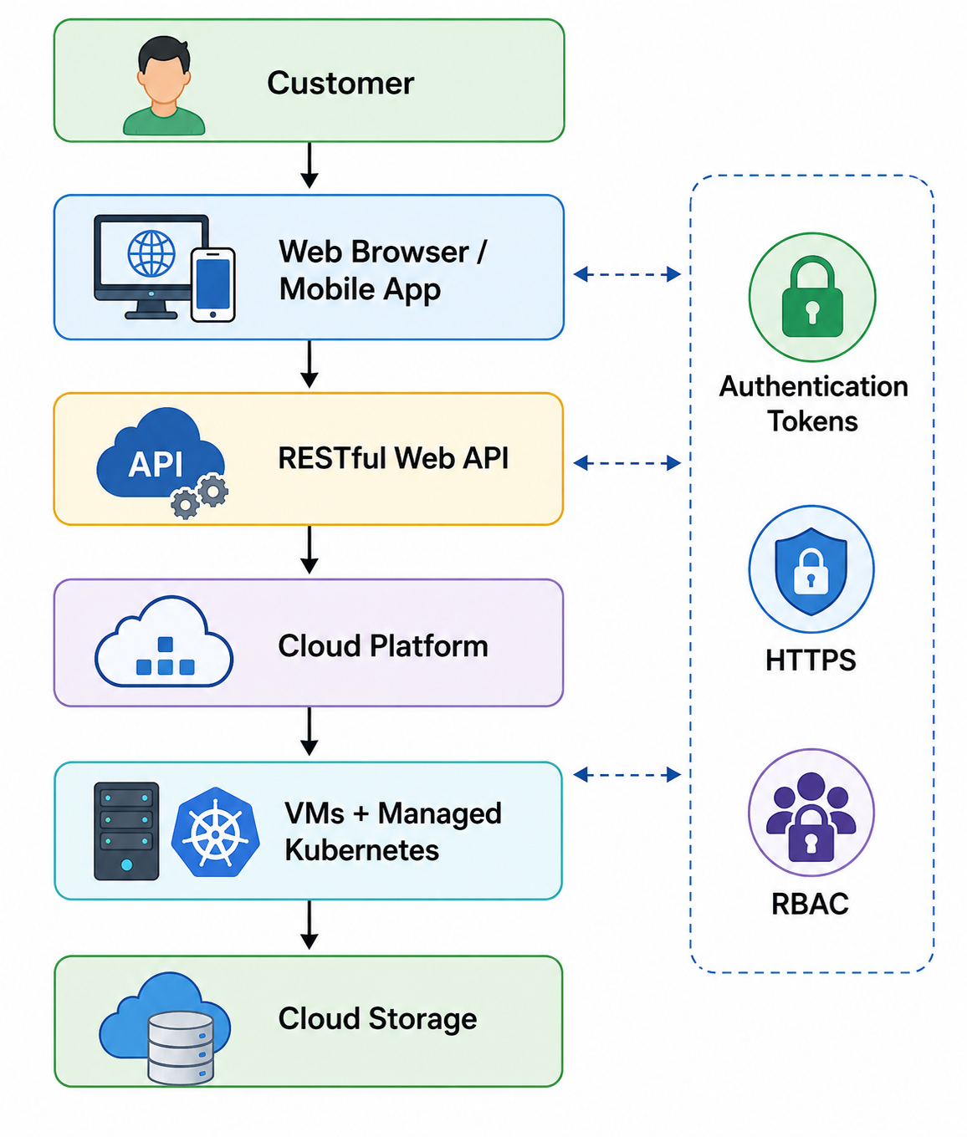
Role of RESTful Web APIs
RESTful APIs provide communication between the frontend clients and backend services.
For example, when a customer opens the application, the frontend can request menu information through an API.
Similarly, when the customer places an order, the application can send the order information to the backend through an API.
This creates a clear separation between the client interface and backend services.
The same backend services can therefore support both web browsers and mobile applications.
Role of Cloud Storage
Cloud storage provides centralized storage for:
- Menu images
- Invoices
- Customer data
The backend services can access the required information from cloud storage.
Centralized cloud storage also makes it easier to manage application data as the platform grows.
Role of Virtual Machines
Virtual machines provide the computing environment required to run backend application services.
They allow the startup to use virtualized computing resources instead of requiring dedicated physical servers for every application component.
This supports the cloud-based infrastructure described in the case.
Role of Managed Kubernetes
Managed Kubernetes is used to manage application workloads and support scalability and reliability.
When the number of requests changes, the cloud infrastructure can manage application workloads more effectively.
This is particularly useful for an online food ordering platform because demand can increase significantly during busy periods.
Security Architecture
Security is implemented using three important mechanisms.
Authentication tokens are used to verify users or services accessing the system.
HTTPS protects information while it travels between the client and backend services.
Role-Based Access Control provides permissions based on the user's role.
For example, a customer should have access to their own orders, while administrative users may have additional permissions to manage platform information.
Scalability
Scalability is important because the platform may start with a small number of users and grow significantly over time.
The use of cloud infrastructure, virtual machines and managed Kubernetes allows the application environment to support changing workloads.
This means the startup does not have to design the entire infrastructure only for its maximum possible future workload from the beginning.
Reliability
Reliability is important because customers expect the ordering platform to be available when they want to place orders.
Managed Kubernetes and cloud infrastructure support reliable application deployment and workload management.
Using cloud services also provides a more flexible infrastructure than relying entirely on a single physical server.
Analysis and Trade-Offs
The cloud architecture provides strong scalability and allows the startup to support both web and mobile clients using the same backend services.
However, the platform becomes dependent on cloud infrastructure and network connectivity. Cloud services can also introduce operational costs as usage increases.
The architecture is more complex than a simple standalone application because it involves APIs, cloud storage, virtual machines, Kubernetes and multiple security mechanisms.
However, for a growing online food ordering platform, the benefits of scalability, reliability, accessibility and centralized services justify this additional complexity.
Expected Benefits
The proposed solution provides:
- Web and mobile accessibility
- RESTful API communication
- Centralized cloud storage
- Secure customer data management
- Scalable infrastructure
- Reliable backend services
- Efficient workload management
- Authentication
- HTTPS security
- Role-based access control
- Easy integration between clients, APIs, storage and cloud services
Conclusion
The proposed cloud-based online food ordering platform effectively integrates frontend clients, RESTful Web APIs, cloud storage, virtual machines and managed Kubernetes.
The architecture is scalable enough to support changing workloads and reliable enough for continuous online operations. Authentication tokens, HTTPS and RBAC provide security for customers and application resources.

